Data Manupilation Language

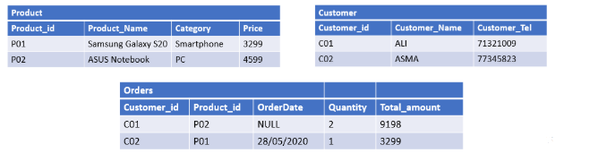

INSERT INTO Product (product_id , product_Name , category , price )

VALUES (‘P01’ , ‘Samung Galaxy S20’ , ‘Smartphone’, ‘3299’),

(‘P02’, ‘ASUS Notebook’ , ‘PC’ , ‘4599’ ) ;

INSERT INTO Customer (customer_id , customer_name ,customer_tel)

VALUES (‘C01’ , ‘ALI’ , ‘71321009’) ,

(‘C02’ , ‘ASMA’ , ‘77345829’) ;

INSERT INTO Orders (Customer_id , product_id , orderdata , quantity , total_amount)

VALUES ( ‘C01’ , ‘P02’ , ‘NULL’ , ‘2’ , ‘9198’),

(‘C02’ , ‘P01’ , ‘28/05/2020’ , ‘1’ , ‘3299’)